Overall band score 6 5+6+7+7
See below C&C LR GRA Model
WRITING TASK 1
You should spend about 20 minutes on this task.
You are part of a group of musicians who meet on Tuesday and Friday evenings to practice in the community hall.
You have been told, however, that it is no longer possible for the group to use the hall.
Write a letter to the manager. In the letter:
• describe what the group does
• explain why the group is good for the community
• suggest alternative days and times for practice
Write at least 150 words.
You do NOT need to write any addresses.
Begin your letter as follows:
Dear ……..

Your answer
Dear Sir,
This letter is in response to your notice disallowing our music group to practice on Tuesday and Friday evenings at the community hall. We would like to take an opportunity to bring to your kind notice that our prime moto is to raise funds for orphanages through events and shows we perform in.
Existence of our group is really critical especially for the orphanages where we donate all our income generated. In fact, for some of the orphanages, we are the only source of income because of the lack of sufficient economic support available by government and remote location of those orphanages.
We understand that there is necessity at your end to make community hall available for certain important purposes at the same time, hence we are flexible to accommodate as per your schedule. Kindly guide us the suitable days and time to practice and we shall plan our schedule as per your convenience.
Would await for your response.
Regards,
Robert

Overall band score 6 5+6+7+7
TA – Task Achievement nb – GRA and LR errors have not been corrected
Band score 5
The purpose is clear. I recommend putting it in a separate paragraph. The tone is appropriate for a letter like this.
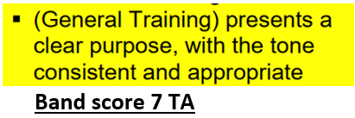

You have addressed the first two bullets and the ideas are relevant. Your first idea could be extended.
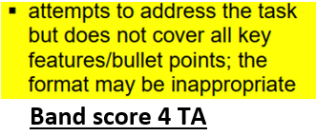
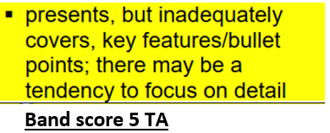
You didn’t fully address bullet 3 – see my comments. This limits your score to 5 for TA. If you hadn’t mentioned alternative days at all it would be a 4 for TA.

Advice On Brainstorming For General Training Task 1
As you’re planning and writing your answer, remember to constantly ask yourself if you’re answering the question. Check back to the question a few times as you think of ideas to make sure they're directly relevant. Your goal should be to make it easy for the examiner to give you a high score
- Make sure your first paragraph states the purpose, eg I am writing to inform you about […] If you’re writing to complain, or to ask a favour, or to inform somebody about some news or information, mention this in the first paragraph. eg I’m writing to inform you of my decision to resign from my position as […]
- Make sure you’ve answered each of the bullet points, and put them in separate paragraphs. Make sure you answer all the bullets directly, and do not give the examiner any chance of saying you covered them inadequately. Ask yourself whether it’s possible that a strict examiner could thing you’ve not answered the question, or one aspect of the question.
- Be especially careful if you’ve answered similar question before; there will always be important differences.
Dear Sir,
This letter is in response to your notice disallowing our music group to practice on Tuesday and Friday evenings at the community hall. We would like to take an opportunity to bring to your kind notice that our prime moto is to raise funds for orphanages through events and shows we perform in.
Existence of our group is really critical especially for the orphanages where we donate all our income generated. In fact, for some of the orphanages, we are the only source of income because of the lack of sufficient economic support available by government and remote location of those orphanages.
We understand that there is necessity at your end to make community hall available for certain important purposes at the same time, hence we are flexible to accommodate as per your schedule. Kindly guide us the suitable days and time to practice and we shall plan our schedule as per your convenience.
Would await for your response.
Regards,
Robert Smith

C&C - Cohesion and Coherence nb GRA and LR errors have not been corrected
Band score 7
There is clear progression throughout and the organisation is logical. It is better to put the introduction in a separate paragraphs.
You could indicate your organisation with more signposting, as shown.
The cohesion is correct apart from one error.
My changes are generally improvements, which show what you need for a higher score.
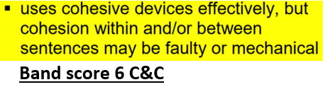
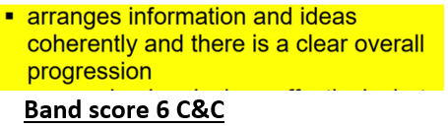

The following are correct signposting phrases for General Training Writing Task 1 questions, not necessarily this one
Phrase | Example
With reference to | With reference to our phone call […]
As far as […] is concerned, | As far as my experience is concerned,
With regard to […] , | With regard to my wallet,
As for […] , | As for the reason why I can’t make it, […]
Regarding […], | Regarding my idea, […]

Paragraphing for General Training Writing Task 1
In a GT letter, I recommend that your first paragraph state the purpose of your letter, and there should be 3 other main body paragraphs, as indicated below. That’s 4 main paragraphs altogether, plus a final one for a closing remark, like I look forward to hearing from you.
Even if you’re writing to a friend, make it easy for the examiner to see the purpose with a sentence like I’m writing to let you know that […] and that […]. To be sure of getting a 7 or higher for TA, you should mention one or of the bullet points, depending on the question.
Write one paragraph per bullet point, and organise them in the same sequence as the bullets in the question. Write around 40 words for each. If you just minimally cover one of the bullets, you cannot assume that it’s ok just to write extra for the others. You need to fully cover them all to get a high score. Note that it’s ok to have relatively short paragraphs of around 40 words in Task 1. It is only in Task 2 that you need topic sentences and supporting ideas.

Dear Sir,
This letter is in response to your notice disallowing our music group to practice on Tuesday and Friday evenings at the community hall.
We would like to take an opportunity to bring to your kind notice the fact that our prime moto is to raise funds for orphanages through events and shows we perform in. For example last year, we […]
In case you didn’t know, the Existence of our group is really critical, especially for the orphanages where we donate all our income generated. In fact, for some of the orphanages, we are their only source of income because of the lack of sufficient economic support available by government and because of the remote location of those orphanages.
As for alternatives, We understand that there is necessity at your end to make community hall available for certain important purposes at the same time, so we are flexible to accommodate as per your schedule. Bearing this in mind, would you Kindly guide us as to which are the suitable days and time to practice and we shall plan our schedule as per your convenience.
Thank you for your attention, and we await for your response.
Regards,
Robert

LR- - Lexical resource nb Some GRA errors have not been corrected.
Band score 7
The vocab is generally good throughout with some flexibility and precision.
There is enough correct less common vocabulary for a band score 7.
Note my suggestions which show the accuracy and precision you need for a higher score.
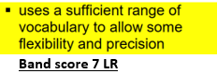
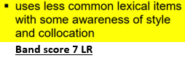
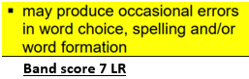

Dear Sir,
This letter is in response to your notice disallowing our music group from practising on Tuesday and Friday evenings at the community hall. We would like to take an opportunity to bring to your attention that our only goal is to raise funds for orphanages through events and shows we perform in.
The Existence of our group is really critical especially for the orphanages where we donate all our income generated. In fact, for some of the orphanages, we are their only source of income because of the lack of sufficient economic support available by government and remote location of those orphanages.
We understand that there is necessity at your end to make community hall available for certain important purposes at the same time, so we are flexible with regard to our schedule. Kindly guide us the suitable days and time to practice and we shall plan our schedule as per your convenience.
Would await for your response.
Regards,
Robert
GRA - Grammatical range and accuracy - nb Some LR errors have not been corrected
Band score 7
There is a range of complex structures with sufficient accuracy to get a band score 7.
Be careful with articles.
You need a higher level of accuracy for an 8 for GRA.
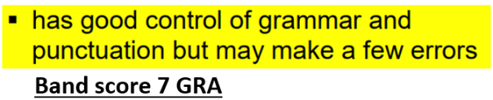
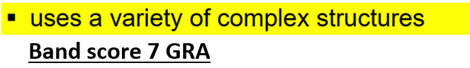
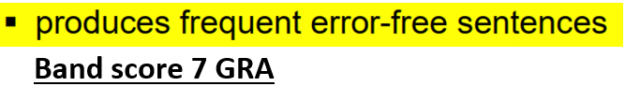

Dear Sir,
This letter is in response to your notice disallowing our music group to practice on Tuesday and Friday evenings at the community hall. We would like to take the opportunity to bring to your notice that our prime moto is to raise funds for orphanages through the events and shows we perform in.
The Existence of our group is really critical, especially for the orphanages where we donate all our income generated. In fact, for some of the orphanages, we are their only source of income because of the lack of sufficient economic support available from the government and because of the remote location of those orphanages.
We understand that there is a necessity at your end to make the community hall available for certain important purposes at the same time, Hence, we are flexible to accommodate as per your schedule. Kindly guide us the suitable days and time to practice and we will plan our schedule as per your convenience.
Thank you for your attention, and we await for your response.
Regards,
Robert

Model answer
None available for the question you did

