Overall band score 7 6+6+8+8
See below CnC LR GRA Model Answer
WRITING TASK 2
You should spend about 40 minutes on this task
Write about the following topic
In some countries, people are no longer allowed to smoke in public spaces and office buildings.
Do you think this is a good rule or a bad rule?
You should spend about 40 minutes on this task
Give reasons for your answer and include any relevant examples from your own knowledge or experience.
Write at least 250 words
Original answer -
Smoking cigarettes is injurious to one’s health and can be annoying and harmful for people in the vicinity. In a few countries, law has been passed that prohibits people from smoking in public places and office buildings. I am strongly in favor of this rule and believe it is a step in the right direction.
Smoking is known to cause various respiratory diseases and cancer which can be fatal. Moreover, the smoke let out by the person smoking can be equally injurious to passers-by and people in the vicinity. The person who smokes can do whatever he pleases to his body but does not have the right to spoil other peoples’ health and put them in harm.
Secondly, smoking leaves a strong stench which can be unpleasant for other people. This often lingers in the space for quite a long time and can be very difficult to get rid of. In offices and public buildings, this can make it difficult for people to even enter such a space let alone get their work done. In addition to this, cigarette lighters and smoked cigarettes that are not extinguished properly can be a potential fire hazard.
In conclusion, I would say that the rule to put a ban on smoking cigarettes in public spaces is a good one. For people who want to smoke they can do so in designated smoking areas thereby preventing others from getting harmed. In fact, I feel more countries should pass legislation to make this rule the law.

Overall band score 7 6+6+8+8
TR – Task Response nb – GRA and LR errors have not been corrected
Band score 6
See my posts on introductions for a simple and effective way of quickly writing an introduction here.
You have addressed the question and the supporting ideas are relevant.
You have a clear position throughout for a clear 7 of TR.
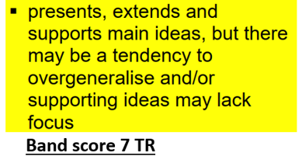
However, you did not make the supporting ideas relevant to the question. You need to make the ideas relevant to the question for a 7.

See C&C for examples of how easy it is.

Advice On Brainstorming For Task 2
As you’re planning and writing your answer, remember to constantly ask yourself if you’re answering the question. Check back to the question a few times as you think of ideas to make sure they're directly relevant.
- Make sure your introduction directly addresses the question.
- Make sure your ideas address all parts of the question. If the question asks for solutions, in the plural, you must suggest at least 2.
- Make sure your main ideas, as stated in the first sentence of the main body paragraphs, are directly relevant to the question.
- Make sure your supporting ideas, which follow the main ideas in the main body paragraphs, directly support the main idea.
- Be especially careful if you’ve answered similar question before, as there will always be important differences.
- Make sure your conclusion directly answers the question, and that it is consistent with the ideas in the main bodies, and that it does not contradict the introduction.

Smoking cigarettes is injurious to one’s health and can be annoying and harmful for people in the vicinity. In a few countries, law has been passed that prohibits people from smoking in public places and office buildings. I am strongly in favor of this rule and believe it is a step in the right direction.
Smoking is known to cause various respiratory diseases and cancer which can be fatal. Moreover, the smoke let out by the person smoking can be equally injurious to passers-by and people in the vicinity. The person who smokes can do whatever he pleases to his body but does not have the right to spoil other peoples’ health and put them in harm.
Secondly, smoking leaves a strong stench which can be unpleasant for other people. This often lingers in the space for quite a long time and can be very difficult to get rid of. In offices and public buildings, this can make it difficult for people to even enter such a space let alone get their work done. In addition to this, cigarette lighters and smoked cigarettes that are not extinguished properly can be a potential fire hazard.
In conclusion, I would say that the rule to put a ban on smoking cigarettes in public spaces is a good one. For people who want to smoke they can do so in designated smoking areas thereby preventing others from getting harmed. In fact, I feel more countries should pass legislation to make this rule the law.

C&C - Cohesion and Coherence nb GRA and LR errors have not been corrected
Band score 6
The organisation is good.
There is clear progression throughout.
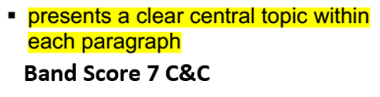
In order to satisfy the examiner the you have clear central topics, you need clearly stated topic sentences.

See my suggestion. In this case, I suggest you could have one main body, which is better than your very short ones.
Your usage of cohesive devices is correct, and I’ve made some improvements.

Paragraphing for Task 2
I recommend you write 4 paragraphs as follows:
- Write an introduction, that explains what the question is. After reading the introduction, the reader should have a good idea what the essay is about, and what your position (opinion) is. It should be possible to write an introduction in under 50 words. It is not necessary to write a long background statement.
- Write 2 main body paragraphs. This should allow you to expand on the ideas sufficiently to persuade the examiner that you’ve fully supported the main ideas. If you write 3 main bodies, it is more difficult to expand and support them sufficiently to get a high score.
- If it’s a two-part question, answer the questions in the order they’re given and write one paragraph per question.
- The main body paragraphs should be 100-120 words, and each paragraph should have a clear topic sentence and 2 or more supporting ideas which support the topic sentence with reasons, evidence, and examples. Do not waste time with lots of background information.
- The topic sentences should directly address the question.
- The conclusion should be consistent with the introduction and the main ideas, and it should not introduce new ideas. It should directly answer the question. Do not leave the examiner in any doubt about whether you’ve answered the question.
- If you write a third paragraph in a discuss both sides question to clarify your position, make sure that give a good reason to reject one of the sides. If you just restated the original ideas about one side, the examiner may decide you have covered one side more than the other.
- It is also ok to write a third body paragraph in a to what extent question if you have main ideas which both agree and disagree with the proposition. Avoid short paragraphs, with under 70 words, as it may be difficult to show a clear central topic in a short paragraph.

Smoking cigarettes is injurious to one’s health and can be annoying and harmful for people in the vicinity. In a few countries, law has been passed that prohibits people from smoking in public places and office buildings. I am strongly in favor of this rule and believe it is a step in the right direction.
I agree that smoking should be banned in certain places because it is harmful to people’s health as well as making the environment unpleasant for non-smokers. With regard to the former, Smoking is known to cause various respiratory diseases and cancer which can be fatal. Another problem is that the smoke let out by the person smoking can be equally injurious to passers-by and people in the vicinity. The person who smokes can do whatever he pleases to his body but does not have the right to spoil other peoples’ health and put them in harm. As for the environment, smoking leaves a strong stench which can be unpleasant for other people. This often lingers in the space for quite a long time and can be very difficult to get rid of. In offices and public buildings, this can make it difficult for people to even enter such a space let alone get their work done. Finally, cigarette lighters and smoked cigarettes that are not extinguished properly can be a potential fire hazard.
In conclusion, I would say that the rule to put a ban on smoking cigarettes in public spaces is a good one. For people who want to smoke they can do so in designated smoking areas thereby preventing others from getting harmed. In fact, I feel more countries should pass legislation to make this rule the law.

LR- - Lexical resource nb Some GRA errors have not been corrected.
Band score 8
Vocabulary is used accurately with sufficient flexibility to show precise meaning, and with only minor inaccuracies, which is good for a band score 8

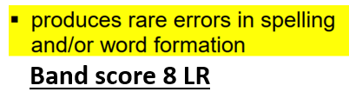
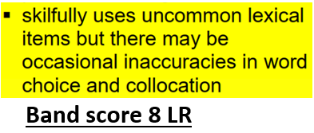
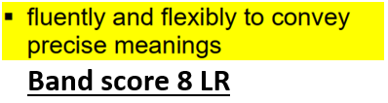
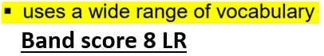

Smoking cigarettes is injurious to one’s health and can be annoying and harmful for people in the vicinity. In a few countries, laws have been passed that prohibits people from smoking in public places and office buildings. I am strongly in favor of this rule and believe it is a step in the right direction.
Smoking is known to cause various respiratory diseases including cancer which can be fatal. Moreover, the smoke let out by the person smoking can be equally injurious to passers-by and people in the vicinity. The person who smokes can do whatever he pleases to his body but does not have the right to spoil other peoples’ health and put them in harm.
Secondly, smoking leaves a strong stench which can be unpleasant for other people. This often lingers in the space for quite a long time and can be very difficult to get rid of. In offices and public buildings, this can make it difficult for people to even enter such a space let alone get their work done. In addition to this, cigarette lighters and discarded cigarettes that are not extinguished properly can be a potential fire hazard.
In conclusion, I would say that the rule to put a ban on smoking cigarettes in public spaces is a good one. For people who want to smoke they can do so in designated smoking areas thereby preventing others from getting harmed. In fact, I feel more countries should pass legislation like this

GRA - Grammatical range and accuracy nb Some LR errors have not been corrected
Band score 8
Grammar is used accurately with relatively few errors, which should be good for a band score 8.
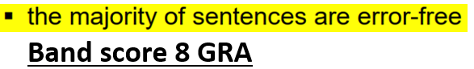
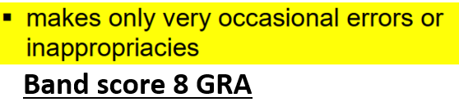

Smoking cigarettes is injurious to one’s health and can be annoying and harmful for people in the vicinity. In a few countries, a law has been passed that prohibits people from smoking in public places and office buildings. I am strongly in favor of this rule and believe it is a step in the right direction.
Smoking is known to cause various respiratory diseases and cancer which can be fatal. Moreover, the smoke let out by the person smoking can be equally injurious to passers-by and people in the vicinity. The person who smokes can do whatever he pleases to his body but does not have the right to spoil other peoples’ health or put them in harm.
Secondly, smoking leaves a strong stench which can be unpleasant for other people. This often lingers in the space for quite a long time and can be very difficult to get rid of. In offices and public buildings, this can make it difficult for people to even enter such a space let alone get their work done. In addition to this, cigarette lighters and smoked cigarettes that are not extinguished properly can be a potential fire hazard.
In conclusion, I would say that the rule to put a ban on smoking cigarettes in public spaces is a good one. For people who want to smoke, they can do so in designated smoking areas, thereby preventing others from getting harmed. In fact, I feel more countries should pass legislation to make this effect.

Model answer
WRITING TASK 2
You should spend about 40 minutes on this task
Write about the following topic
Some people think that the increasing use of computers and mobile phones for communication has had a negative effect on young people's reading and writing skills.
To what extent do you agree or disagree?
You should spend about 40 minutes on this task
Give reasons for your answer and include any relevant examples from your own knowledge or experience.
Write at least 250 words
KEY
C&C bold
LR italics
GRA underlined
Opinions are divided on whether the use of modern communication devices like computers and mobiles has adversely affected young people’s literacy skills. I believe that the opposite is the case, and their reading and writing skills both benefit from using these devices
Although it is generally thought that the use of abbreviations and slang has a detrimental effect on young people’s ability to write, in practice, this does not happen. Evidence for this can be seen in the fact that people who use slang in spoken English can quite easily adapt their language appropriately when speaking in a formal situation or to their parents, and the same applies to written English. Children adopt these shortcuts because they are quicker and easier, as well as being the norm, and just because a child uses “LOL” does not mean he will forget how to spell “laugh”.
In fact, far from being affected adversely, young people are reading and writing more than in the past, which means they benefit from this technology. This is because it is not possible to write text messages, write emails, or even read one’s friends’ Facebook posts, if one cannot read in the first place. In the past, some of these young people would have wasted their time watching cartoons on TV, but now they are practising their reading and writing skills actively. The truth is that far more written communication takes place nowadays by people of all ages as a result of technology, and even older people admit that when they were young they rarely hand wrote letters.
In conclusion, these modern communication devices do not harm literacy skills; on the contrary, they have a positive impact on them.
282 words

